|  |
| --- |
| **<<NOUGHTS & CROSSES>>**  **21CSS101J – PROGRAMMING FOR PROBLEM SOLVING**  **Mini Project Report**  *Submitted by*  **Student Name: - Amritanshu Mukherjee**  **[Reg. No.: RA2211026010220]**  **B.Tech. CSE - <<specialization in AI & ML>>**  **Student Name: - Rushil Adkane**  **[Reg. No.: RA2211026010260]**  **B.Tech. CSE - <<specialization in AI & ML>>**  **SRMIST-01.jpg**  **SCHOOL OF COMPUTING**  **COLLEGE OF ENGINEERING AND TECHNOLOGY**  **SRM INSTITUTE OF SCIENCE AND TECHNOLOGY**  **(Under Section 3 of UGC Act, 1956)**  S.R.M. NAGAR, KATTANKULATHUR – 603 203  **December 2022** |

**TABLE OF CONTENTS**

|  |  |  |
| --- | --- | --- |
| **Chapter No.** | **Title** | **Page No.** |
| 1 | Problem Statement | 3 |
| 2 | Methodology / Procedure | 4-6 |
| 3 | Coding (C or Python) | 7-8 |
| 4 | Results | 9-10 |
| 5 | Conclusion | 10 |

***PROBLEM STATEMENT***

***How to create any game using Python Programming Language using Functions?***

***PROCEDURE***

***The basic procedure for creating the following game is as follows: -***

* ***The first step is to open Google Colab and sign in to the account.***
* ***Be clear about the functions one need to use.***
* ***First define the sum function which will be used later for adding up the number of index values in the list.***
* ***Then define the printboard function which is used to print the format of tic tac toe and it replaces the value of index with either ‘X’ or ‘O’.***
* ***Define a new function named checkwin which checks whether a user won the match or not. The ways a user can win a match is as follows.***

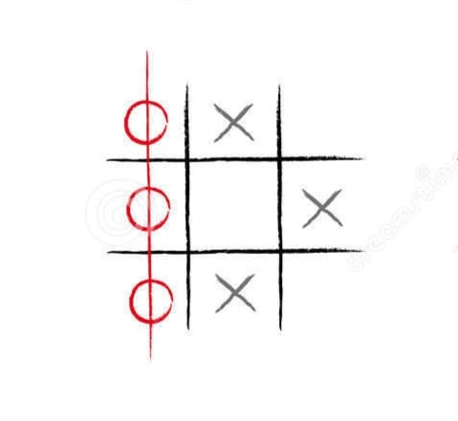

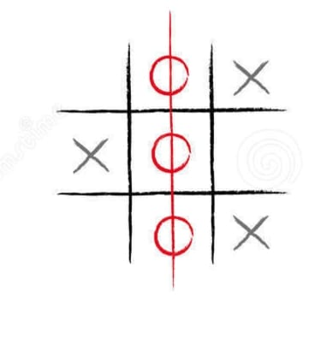

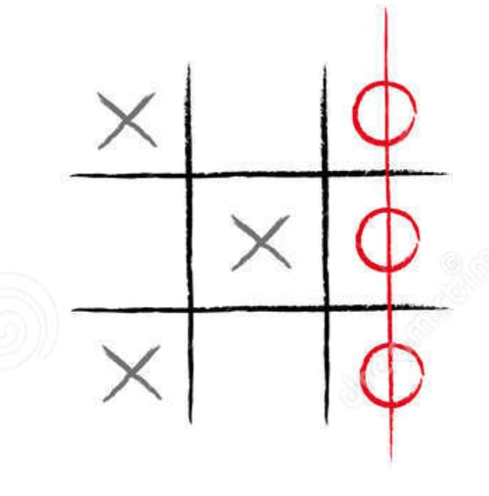

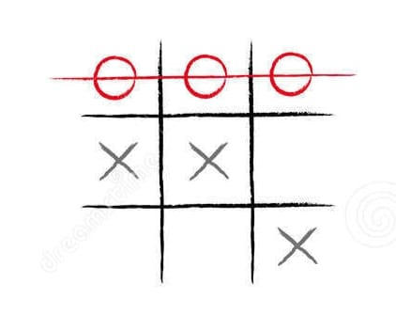

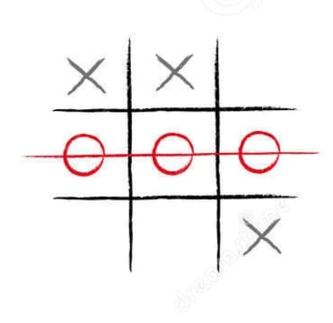

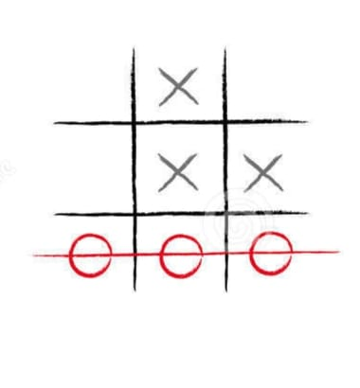

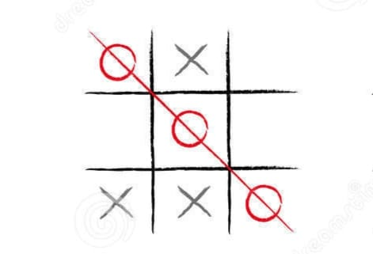

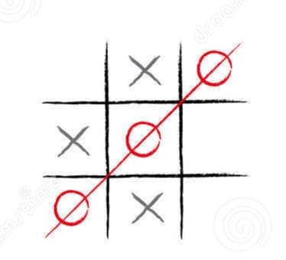

* ***Then in the main function declare two variables which can store the index values of ‘X’ and ‘O’, i.e. it will be storing 0 at (0-8) index values and the place where ‘X’ or ‘O’ will be placed the value at that index will be made 1.***
* ***We also declare a variable turn which changes the turn of the user. Suppose if it was the turn of ‘X’ this time it will be changing and next time it will be turn of ‘O’.***
* ***We will call the checkwin function in the variable cwin and then check if the value of cwin of -1 or not. If the value of cwin is not -1 then either ‘X’ or ‘O’ wins and if it returns -1 then the game continues and if all the indexes are full it would be showing the match is drawn.***

***Coding (Python)***

***The code for creating the game tic tac toe is as: -***

def sum(a, b, c):

  return a+b+c

def printboard(xstate, zstate):

  zero= 'X' if xstate[0] else ('O' if zstate[0] else 0)

  one= 'X' if xstate[1] else ('O' if zstate[1] else 1)

  two= 'X' if xstate[2] else ('O' if zstate[2] else 2)

  three= 'X' if xstate[3] else ('O' if zstate[3] else 3)

  four= 'X' if xstate[4] else ('O' if zstate[4] else 4)

  five= 'X' if xstate[5] else ('O' if zstate[5] else 5)

  six= 'X' if xstate[6] else ('O' if zstate[6] else 6)

  seven= 'X' if xstate[7] else ('O' if zstate[7] else 7)

  eight= 'X' if xstate[8] else ('O' if zstate[8] else 8)

  print(f"{zero} | {one} | {two} ")

  print(f"--|---|---")

  print(f"{three} | {four} | {five} ")

  print(f"--|---|---")

  print(f"{six} | {seven} | {eight} ")

def checkwin(xstate, zstate):

  wins=[[0, 1, 2], [3, 4, 5], [6, 7, 8], [0, 3, 6], [1, 4, 7], [2, 5, 8], [0, 4, 8], [2, 4, 6]]

  for win in wins:

    if(sum(xstate[win[0]], xstate[win[1]], xstate[win[2]])==3):

      print("X won the match")

      return 1

    if(sum(zstate[win[0]], zstate[win[1]], zstate[win[2]])==3):

      print("O won the match")

      return 0

    if xstate.count(1)+zstate.count(1)==9:

      print("The match is drawn")

      return 2

  return -1

if __name__== "__main__":

  xstate= [0, 0, 0, 0, 0, 0, 0, 0, 0]

  zstate= [0, 0, 0, 0, 0, 0, 0, 0, 0]

  turn = 1 # 1 for X and 0 for O

  print("Welcome to Noughts & Crosses")

  while(True):

    printboard(xstate, zstate)

    if(turn == 1):

      print("X's Chance")

      value= int(input("Please enter a value: "))

      xstate[value] = 1

    else:

      print("O's Chance")

      value= int(input("Please enter a value: "))

      zstate[value] = 1

    cwin = checkwin(xstate, zstate)

    if(cwin != -1):

        print("Match Over")

        break

    turn = 1- turn

***RESULTS: -***

***Welcome to Tic Tac Toe***

***0 | 1 | 2***

***--|---|---***

***3 | 4 | 5***

***--|---|---***

***6 | 7 | 8***

***X's Chance***

***Please enter a value: 0***

***X | 1 | 2***

***--|---|---***

***3 | 4 | 5***

***--|---|---***

***6 | 7 | 8***

***O's Chance***

***Please enter a value: 4***

***X | 1 | 2***

***--|---|---***

***3 | O | 5***

***--|---|---***

***6 | 7 | 8***

***X's Chance***

***Please enter a value: 8***

***X | 1 | 2***

***--|---|---***

***3 | O | 5***

***--|---|---***

***6 | 7 | X***

***O's Chance***

***Please enter a value: 2***

***X | 1 | O***

***--|---|---***

***3 | O | 5***

***--|---|---***

***6 | 7 | X***

***X's Chance***

***Please enter a value: 6***

***X | 1 | O***

***--|---|---***

***3 | O | 5***

***--|---|---***

***X | 7 | X***

***O's Chance***

***Please enter a value: 7***

***X | 1 | O***

***--|---|---***

***3 | O | 5***

***--|---|---***

***X | O | X***

***X's Chance***

***Please enter a value: 3***

***X won the match***

***Match Over***

***Conclusion: -***

***The tic tac toe game was successfully created and is executed successfully. All the conditions which needs to be matched in the game Tic Tac Toe have been looked for and have tried to include all the conditions in the game.***